**Node.js - Top 100 Interview Questions and Answers**

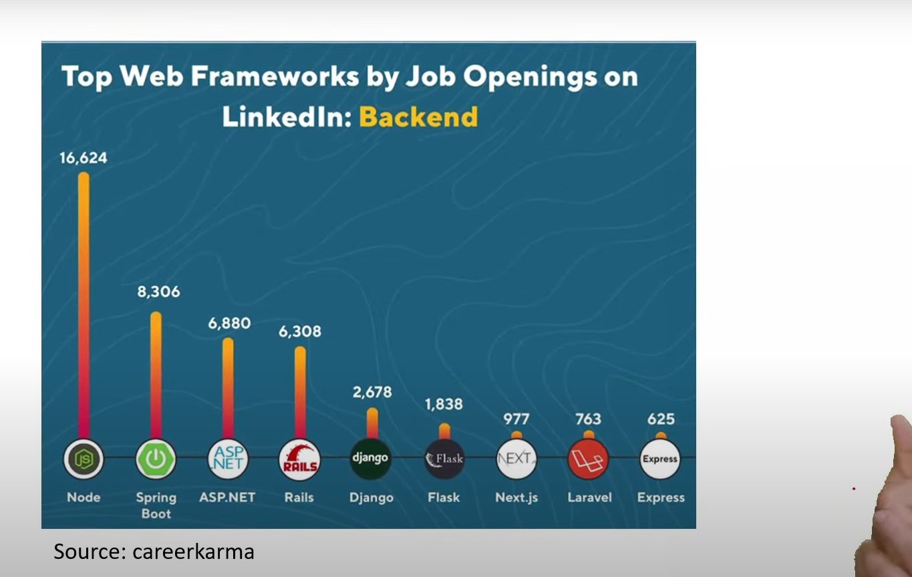

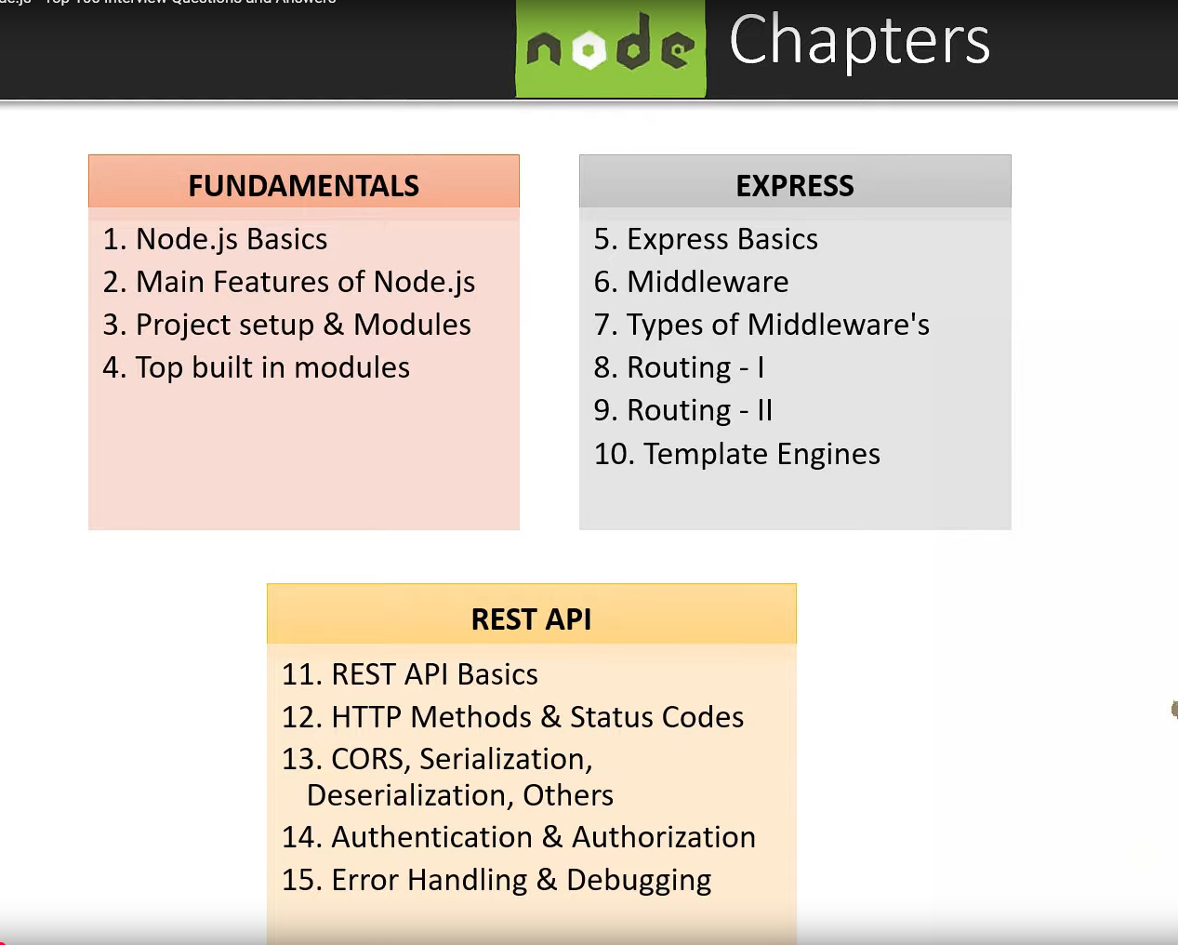

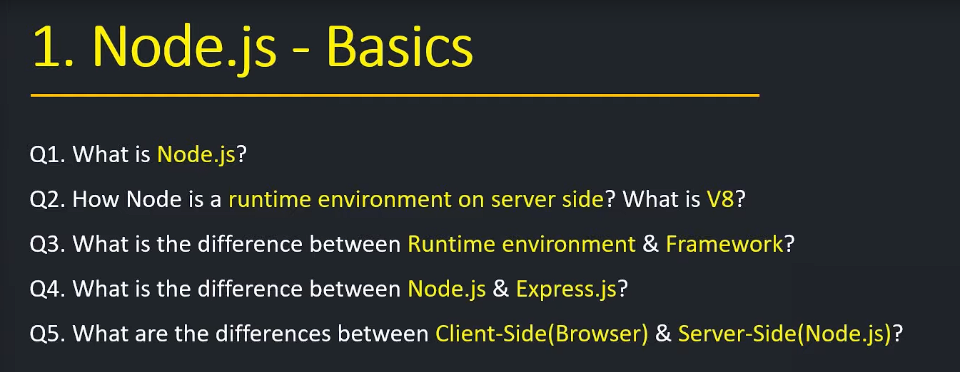

1. **What is Node.js?**

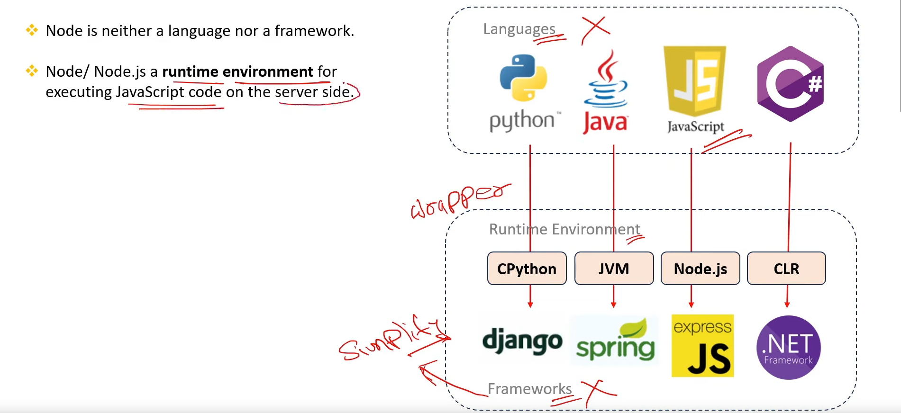

1. **How Node is a runtime environment on server side? What is v8?**

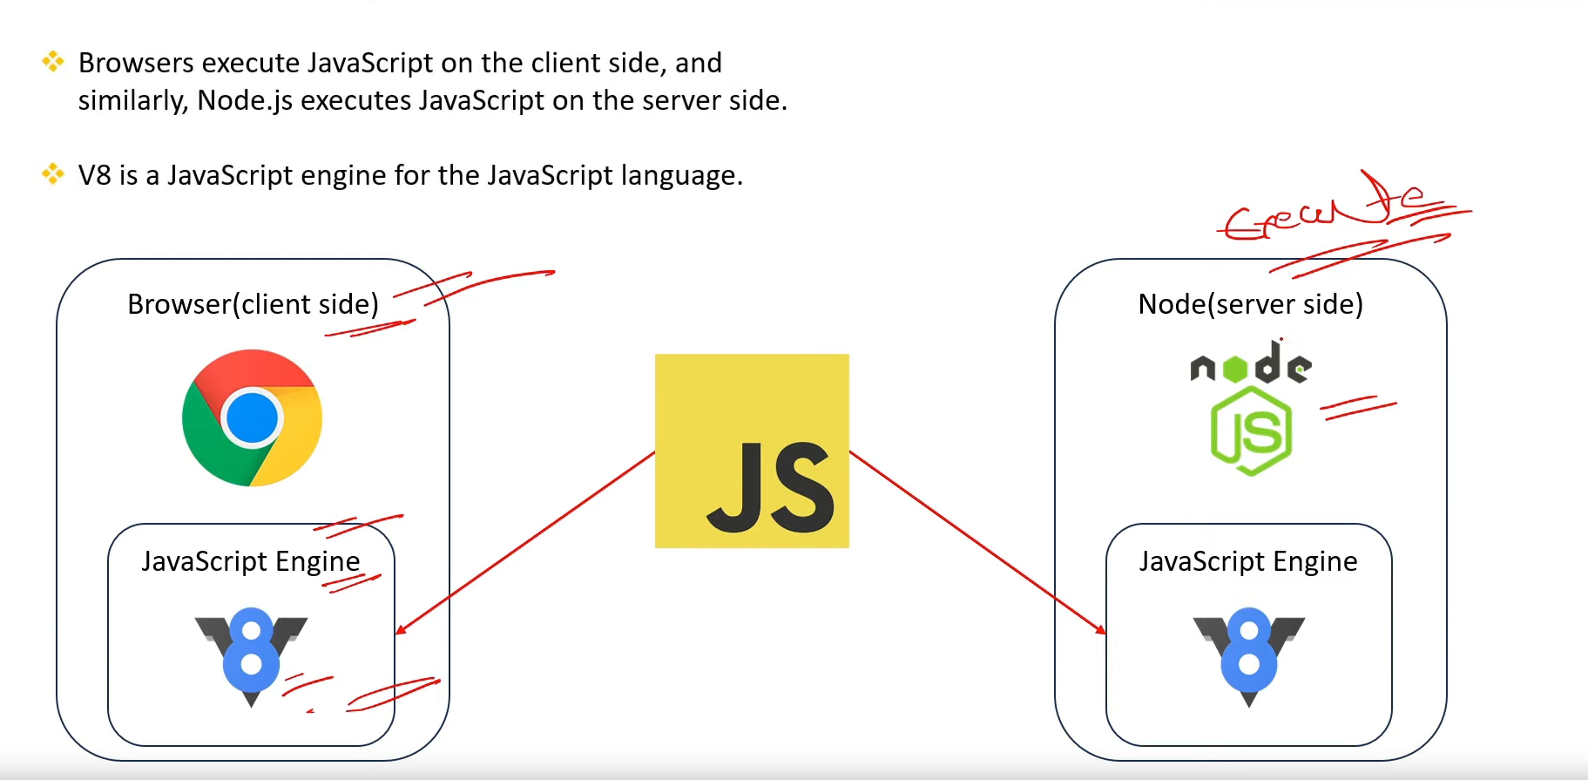

1. **What is the difference btw Runtime Environment & Framework?**

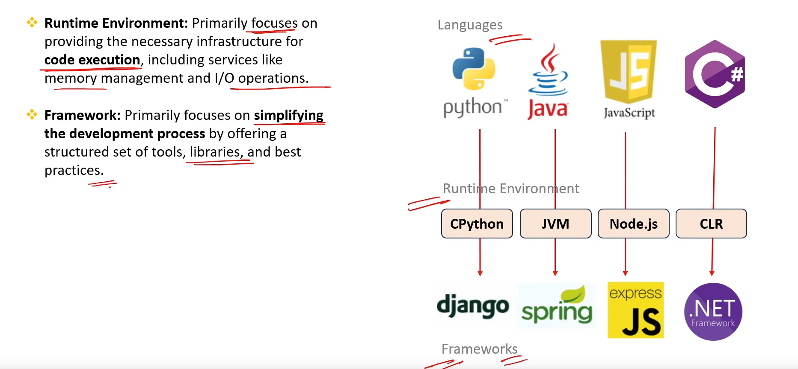

1. **What is the difference btw Node.js and Express.js?**

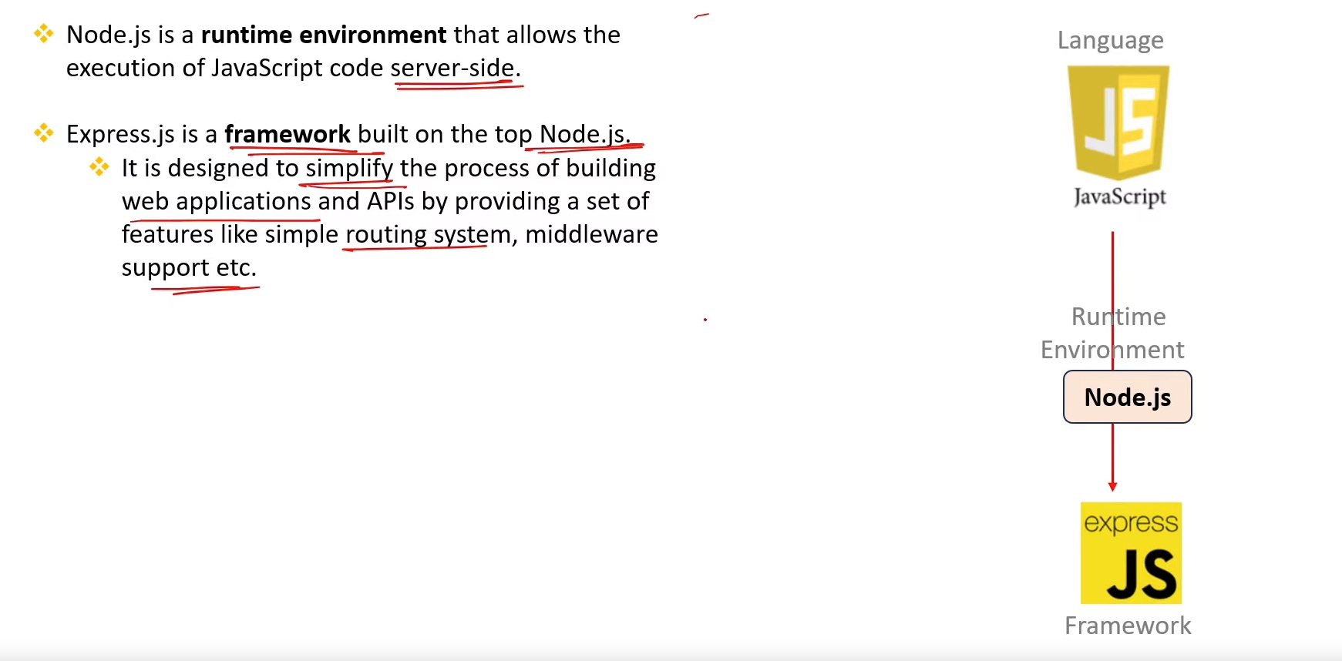

1. **What is the difference btw Client-Side(Browser)& Server-Side(Node.js)?**

